**CMPE-250 Laboratory Exercise Nine**

**Serial I/O Driver**

By submitting this report, I attest that its contents are wholly my individual writing about this exercise and that they reflect the submitted code. I further acknowledge that permitted collaboration for this exercise consists only of discussions of concepts with course staff and fellow students; however, other than code provided by the instructor for this exercise, all code was developed by me.



Dean Trivisani

Performed October 31, 2017

Submitted November 6, 2017

Lab Section 01L2

Instructor: Melton

TA: Donald Mannise

Michael Baumgarten

Matthew Toro

Lecture Section 01

Professor: Melton

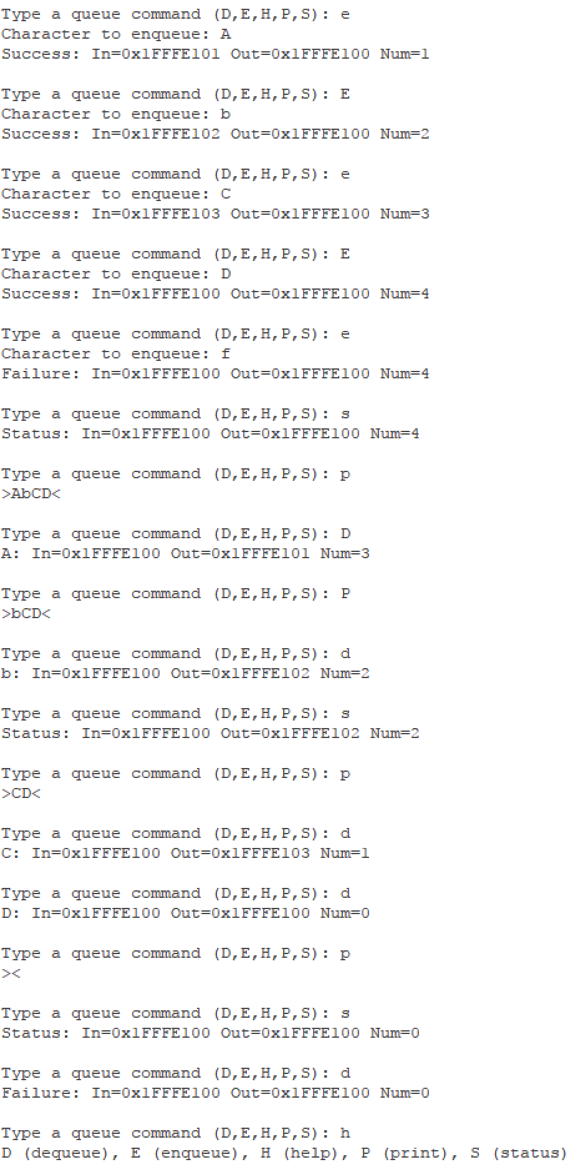

These screenshots (the right screenshot being a continuation of the operations on the left) show the program correctly handling both upper and lowercase commands, correctly failing or succeeding at operations when the queue is empty, populated, and full, and demonstrates the circular buffer by enqueuing and dequeuing a character after the BufferPast address has been reached.

**Code Area Starting Addresses Size (bytes) Ending Address**

Executable Code 0x00000410 1244 0x000008EB

UART0_ISR 0x000007F5 78 0x00000842

ROM Constants 0x000001FC 168 0x000002A3

Program QBuffer RAM 0x1FFFE100 4 0x1FFFE103

Program QRecord RAM 0x1FFFE100 18 0x1FFFE117

Receive QBuffer RAM 0x1FFFE118 4 0x1FFFE11B

Receive QRecord RAM 0x1FFFE11C 18 0x1FFFE129

Transmit QBuffer RAM 0x1FFFE130 4 0x1FFFE133

Transmit QRecord RAM 0x1FFFE134 18 0x1FFFE145